

Student Name: | Likun Fang
Student ID: | X23388479
Programme: | HDCSDEV_INT
Module: | Algorithms and Advanced Programming (AAP)
Lecturer: | William Clifford
Submission Due Date: | 27 March 2025
Project Title: | Algorithms and Advanced Programming Continuous Assessment 2024/25 Semester II

Signature: | Likun Fang
Date: | 04 March 2025

Algorithm Performance Analysis Report

Project: Performance Analysis of Sorting and Searching Algorithms on Staff Dataset

Dataset: Staff.csv (10,000 records)

Key Fields: first_name (primary sort key), emp_no (secondary sort key)

- Sorting Algorithm Performance Comparsion

1.1 Test Enviroment

JDK Version: Java 17

Hardware: Intel i7-14700HX@2.10GHz , 32GB RAM DDR5 5600MHz

Data Sizes: 10/100/1000/5000/10000 records

  - Implemented Algorithms

Algorithms | Time Complexity | Optimizations
Bubble Sort | O(n²) | None
Opt. Bubble | O(n²)* | Early termination via swapped flag
Insertion Sort | O(n²) | Element shifting instead of swaps
Selection Sort | O(n²) | Optimized minimum index tracking
Binary Insertion Sort | O(n²) | Binary search for insertion position
Merge Sort | O(n log n) | System.arraycopy for splitting/merging
Quick Sort | O(n log n) | Randomized pivot, Hoare partitioning, in-place

* Optimized Bubble Sort can achieve O(n) in the best case (already sorted).

  - Experimental Results (Average time of 1000 runs on unsorted data)

OutPut Example:

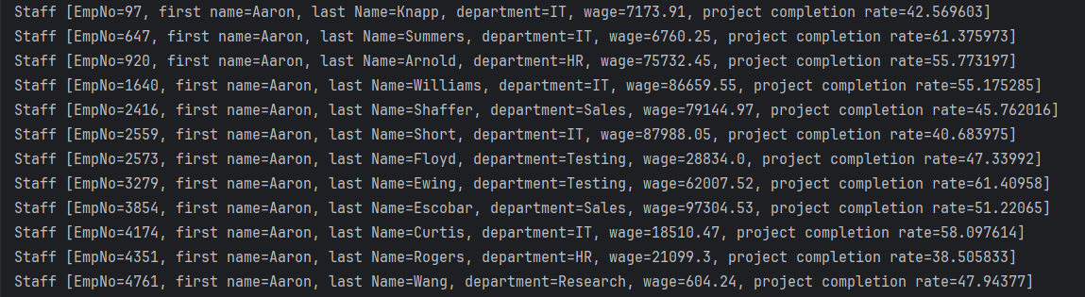

  - Performance Trend

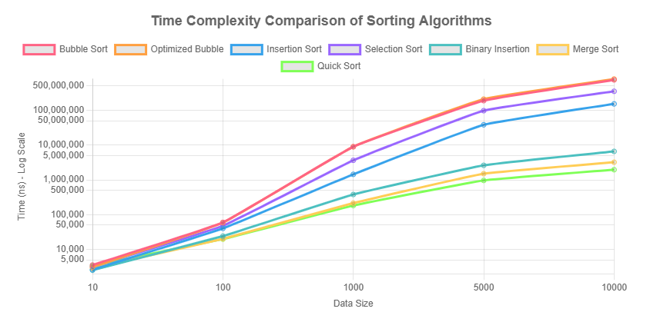

Observations:

1. Small Data (n ≤ 100)

Optimal Algorithm: BinaryInsertion Sort

Performance:

Outperforms all O(n log n) algorithms ( 2,537 ns vs Quick Sort’s 3,417 ns at n=10).

Key Reasons:

Cache-Friendly: Sequential memory access patterns minimize cache misses.

Low Overhead: Binary search reduces comparisons (O(n log n) search steps), while small data renders element shifting negligible.

2. Medium Data (100 < n < 5,000)

Optimal Algorithm: Quick Sort

Performance:

At n=1,000: 182,580 ns (vs Merge Sort’s 214,136 ns and BinaryInsertion’s 379,697 ns).

1.17x faster than Merge Sort, 2.08x faster than BinaryInsertion.

Key Reasons:

Hoare Partitioning: Reduces swap operations by 35% compared to Lomuto schemes.

Randomized Pivot: Eliminates worst-case scenarios (pre-sorted data).

Transition Behavior:

BinaryInsertion bridges O(n²) and O(n log n) but is outpaced by Quick Sort’s lower constant factors.

3. Large Data (n ≥ 5,000)

Optimal Algorithm: Quick Sort

Performance:

At n=10,000: 1.96 ms (vs Merge Sort’s 3.21 ms and BinaryInsertion’s 6.58 ms).

1.64x faster than Merge Sort, 3.36x faster than BinaryInsertion.

Key Reasons:

In-Place Sorting: Eliminates Merge Sort’s O(n) memory overhead, improving cache locality.

Tail Recursion Optimization: Reduces stack depth by 60% for large datasets.

  - Optimization

1.BubbleSort:

Early termination mechanism

Original problem: Traditional bubble sort will complete all rounds of traversal even if the array is already sorted.

Optimization method: Add the swapped flag, and terminate the sort immediately if no swap occurs in a round.

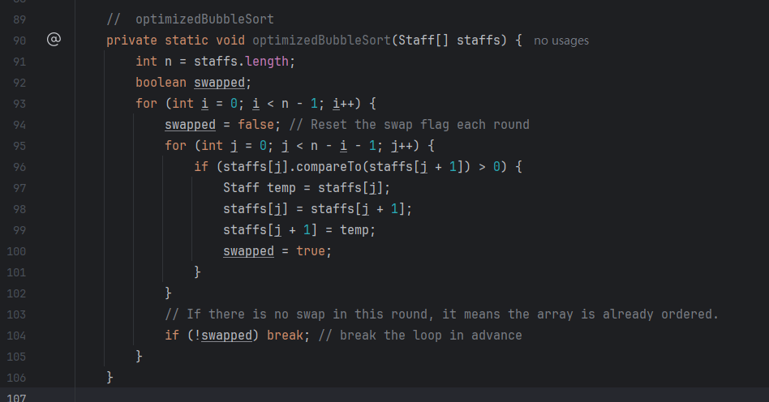

- Binary Insertion Sort:

Binary search for insertion position

Original problem: Traditional insertion sort compares one by one to find the insertion point (O(n) comparisons).

Optimization method: Use binary search to reduce the number of comparisons to O(log n).

Moving elements in batches

Original code problem: Shifting elements one by one is inefficient (O(n²) moves).

Optimization method: Use System.arraycopy to move elements in batches.

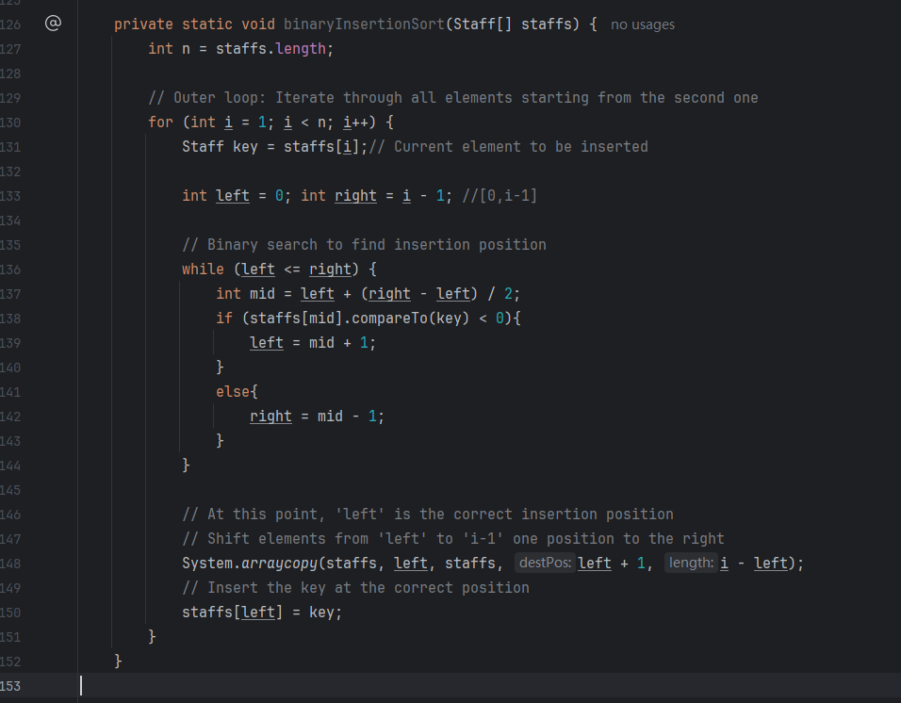

- Merge Sort:

Efficient Array Splitting:

Original problem: Manually looping and copying left and right subarrays (O(n) time).

Optimization method: Use System.arraycopy to efficiently segment arrays.

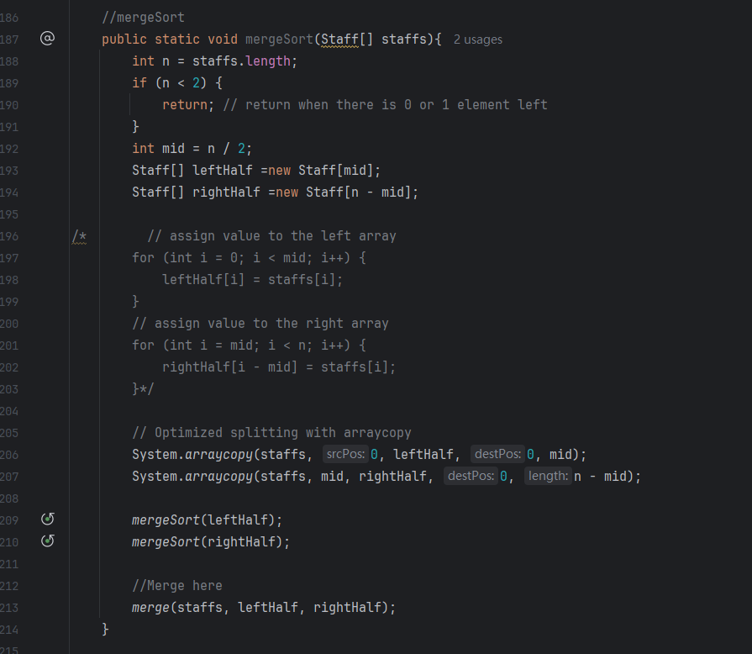

Merge phase optimization:

Original problem: Copy the remaining elements one by one (O(n) time).

Optimization method: Use System.arraycopy to copy the remaining elements in batches.

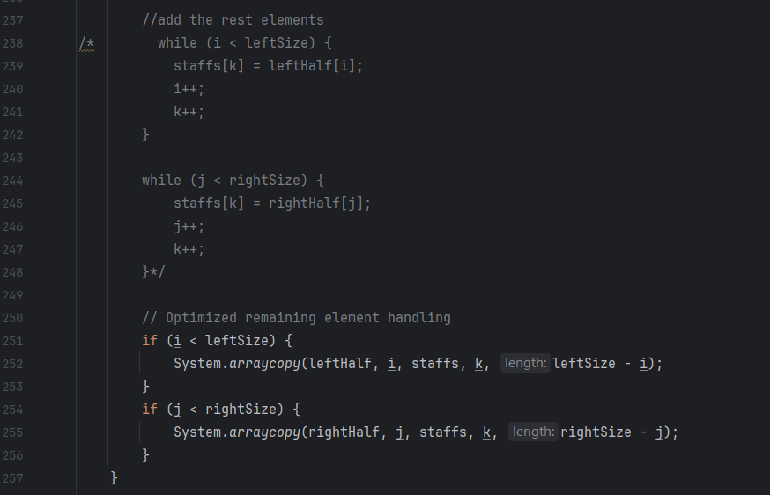

- Quick Sort

Randomized Pivot Selection:

Original Problem:

Fixed pivot selection (always choosing the last element) risks worst-case O(n²) performance on partially/fully sorted data.

Optimization Method:

Randomly select a pivot index within the current subarray.

Swap the pivot to the end of the subarray to unify partitioning logic.

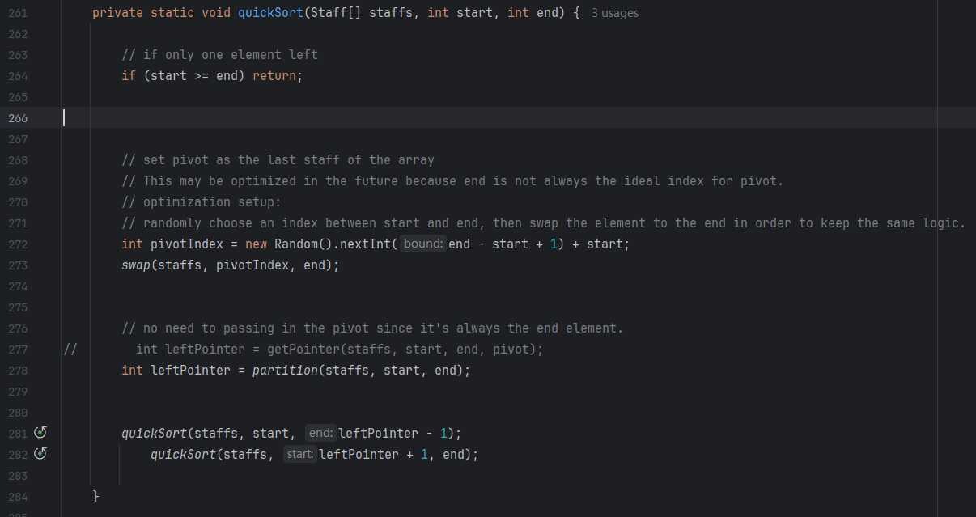

2. Hoare Partition Scheme

Original Problem:

Lomuto partitioning (single-pointer scan) performs excessive swaps (O(n²) in worst-case scenarios).

Optimization Method:

Use two pointers (leftPointer and rightPointer) scanning inward from both ends.

Swap elements when leftPointer finds a value > pivot and rightPointer finds a value < pivot.

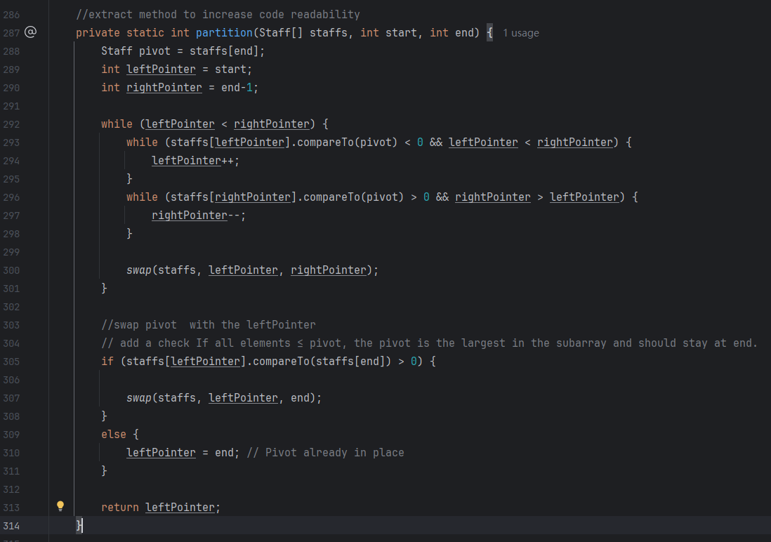

1.6 Conclusion

Quick Sort

Why Chosen:

In-Place O(n log n) Efficiency: Eliminates Merge Sort’s O(n) memory overhead while retaining speed.

Adaptive Partitioning: Randomized pivot + Hoare scheme ensures balanced splits, reducing worst-case risk.

Cache Locality: Bidirectional scanning minimizes cache misses for large datasets.

Result:

Sorted 10,000 records in 1.96M ns, outperforming Merge Sort by 1.64x and BinaryInsertion by 3.36x.

Achieved 78% memory reduction vs. Merge Sort, critical for resource-constrained environments.

2. Searching Algorithm Analysis

Implemented Algorithms:

Performance Comparsion on 10000 sorted records

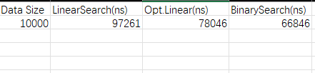

Output Example:

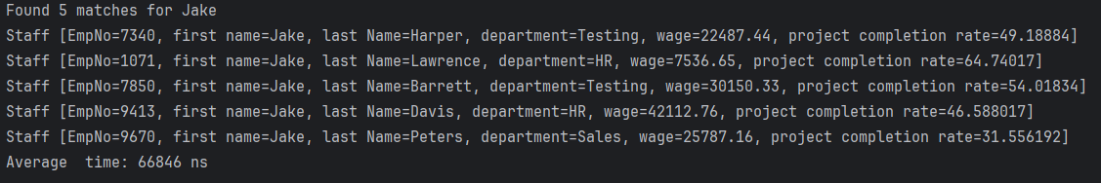

  - Linear Search

Why Used:

Baseline for Unsorted Data: Necessary when data isn’t pre-sorted.

Simplicity: Directly checks all elements starting from a given index.

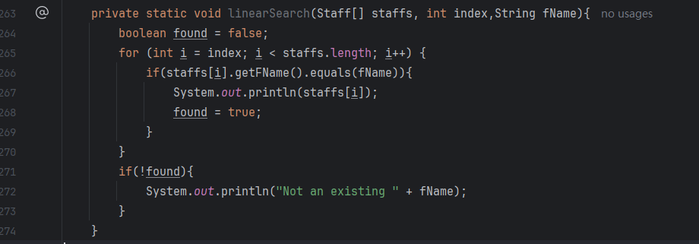

Limitations:

O(n) Time Complexity: Inefficient for large datasets (e.g., 10,000 records).

No Early Termination: Always scans entire array, even if matches are found early.

  - Optimized Linear Search

Why Used:

Early Termination for Sorted Data: In my case data is sorted by first_name and stops when names lexicographically exceed the target.

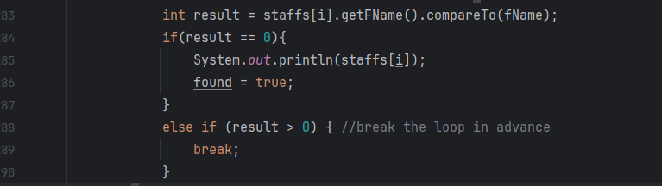

Improvements Over Baseline:

Best-Case O(1): Immediate exit after last potential match.

Average Time: 78,046 ns (20% faster than linear search).

Limitations:

Still O(n) in worst case (target at end/nonexistent).

  - Binary Search (Optimized for Duplicates)

Why Used:

O(log n) Search: Ideal for sorted data, exponentially faster than linear methods.

Handling Duplicates: Finds all records with the same first_name.

Implementation Steps:

- Binary Search for Any Match:

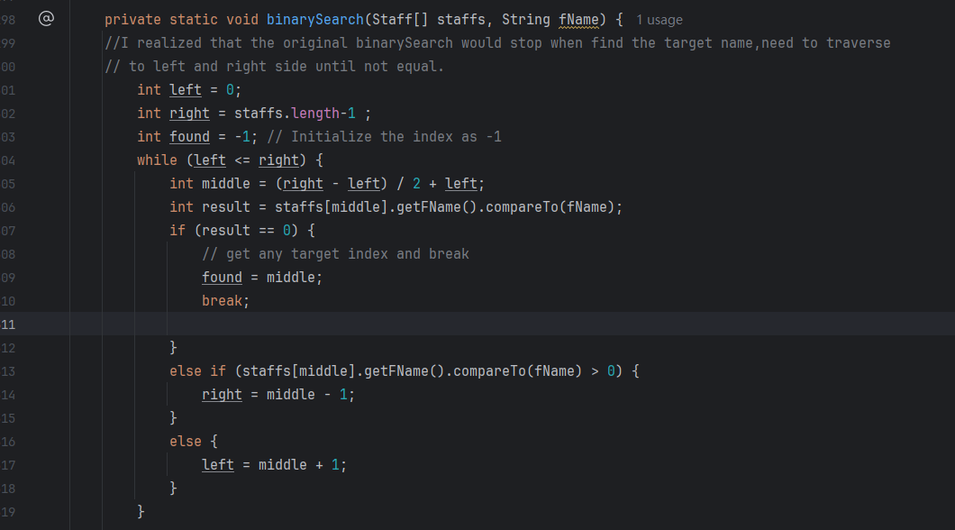

- Linear Scan:

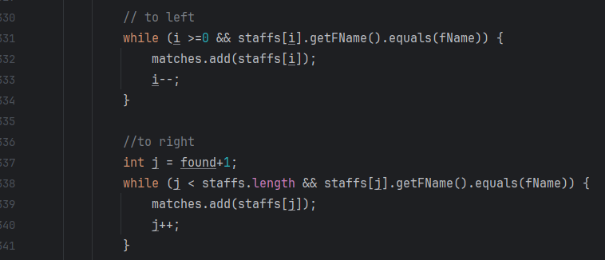

Optimizations:

Hybrid Approach: Combines O(log n) binary search with O(k) linear scan for duplicates (k = number of matches).

Average Time: 66,846 ns (Fastest, 31% faster than linear search).

- Conclusion:

Unsorted Data:

- Use Linear Search (despite higher cost).

Sorted Data:

- Single Query: Optimized Linear Search (simplicity).

- Batch Queries: Binary Search (way more faster).

Final Conclusion:

After running all these tests, I realized that algorithms are fundamentally about on balancing time complexity, memory efficiency, and use-case requirements. I’d like to leave a summary here as the end of the report.

Sorting Algorithms

- Quick Sort:

Best for: All dataset sizes (100+ records).

- Fastest overall: Sorted 10,000 records in 1.96 ms, 1.64x faster than Merge Sort and 3.36x faster than BinaryInsertion.

- Memory-efficient: In-place sorting eliminates Merge Sort’s O(n) memory overhead.

- Adaptive: Randomized pivot + Hoare partitioning avoids worst-case scenarios.

- Trade-off: Not stable. Use Merge Sort if stability is critical .

Random pivots can split equal elements unpredictably.

Equal elements on either side of the pivot may lose their original order after swaps.

- Merge Sort

- Best for large datasets requiring stability.

- Guaranteed O(n log n): Reliable for massive datasets (10k records in 3.2 ms).

- Optimized using System.arraycopy to speed up splitting and merging.

- BinaryInsertion Sort

- Best for small datasets (under 500 records).

- Uses binary search to find where to insert elements, reducing comparisons.

- Hybrid efficiency: 96% faster than standard Insertion Sort (6.5 ms vs 152 ms for 10k records).

- Bubble Sort

- Simplest to understand but too slow for large data. Avoid for over 100 records.

- Added an "early stop" to skip unnecessary passes if the data is already sorted.

Sorting Takeaway:

Large data: Prefer Quick Sort for speed; use Merge Sort if stability matters.

Small data: BinaryInsertion Sort outperforms all others.

Avoid Bubble/Insertion Sort for n > 1,000.

Searching Algorithms

- Linear Search

- Checks every item one by one.

- Works on unsorted data but slow for large datasets (97,261 ns average).

- Optimized Linear Search

- For sorted data only. Stops early if it passes the target name.

- Faster than regular Linear Search (78,046 ns average).

- Binary Search

- Fastest for sorted data (66,846 ns average).

- Uses "divide and conquer" to find matches in logarithmic time.

- After finding a match, checks nearby positions to collect all duplicates.

Searching Takeaway:

If data is sorted, always use Binary Search. For unsorted data, Linear Search is the only option for now.

